Elements of Econometrics. 2022-2023.
Seminar 1. Introduction.
Class Teacher: Elena Semerikova
esemerikova@hse.ru

PLAN

- Expectation, variance, covariance, correlation
- Properties of estimators: unbiasedness, efficiency, consistency
- Convergence in distribution, convergence in probability

EXPECTATION, VARIANCE, COVARIANCE, CORRELATION

Problem 1. Swedish scientists have found that people who ride a bicycle are significantly less likely to have heart attacks. Correlation coefficient between hours of riding bicycle and number of cases of heart attacks was / (it is significant). How can you interpret this result?

Problem 2. “Correlation does not imply causation”. You have data from ten Russian cities. You know overall city damage caused by fire and number of fireman teams. You calculate the correlation coefficient between damage and number of teams and get a value of 0.85 (it is significant). How can you interpret this result?

Problem 3: If X and Y are independent then /. (Independence Imply zero correlation).

Problem 4: If /, then X and Y are not necessarily independent.
(Zero Covariance Does Not Necessarily Imply Independence).

Problem 5. Let / and /. Define /. Find /and /.
Problem 6. Let / and /. Show that /.

PROPERTIES OF ESTIMATORS

Problem 7. A random variable / has unknown population mean / and population variance /. A sample of / observations / is generated. The average of the odd-numbered observations is used to estimate /.
a) Determine whether this estimator is unbiased.
b) Determine whether this estimator is efficient.
c) Determine whether this estimator is consistent.

Problem 8. A random variable X has unknown population mean μ_{X} and population variance /. A sample of n observations {X₁, ..., X_{n}} is generated. Show that
/
is an unbiased estimator of μ_{X}. Show that the variance of Z does not tend to zero as n tends to infinity and that therefore Z is an inconsistent estimator, despite being unbiased.
Comment: Some students during the seminar made a remark that the formula for the estimator in this question is probably mistaken
//
and should be corrected in the following way
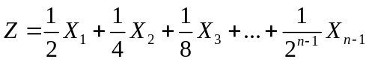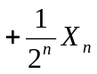
The teacher replied that there is no mistake in the question, but their correction is sensible as a version of the question for the future examinations.
Questions to discuss

- What is the methodology of econometrics?
- What are main types of data in econometrics?
- What is consistency?
- Why sample size is important in econometrics?

Additional problems.

Problem 9. A random variable X has unknown population mean μ_{X} and population variance 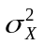. A sample of n observations {X₁, ..., X_{n}} is generated. Investigate whether estimator
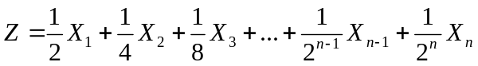
is consistent estimator of μ_{X}.
Problem 10. A random variable X has population mean μ and variance σ². Given a sample of n independent observations X_{i}, i = 1, ..., n, determine whether the following estimator of μ
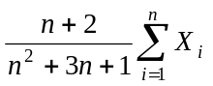
is consistent (you may assume that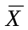is a consistent estimator).

Problem 11. A random variable X has population mean μ and variance σ². Given a sample of n independent observations X_{i}, i = 1, ..., n, determine whether the following estimator of μ

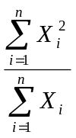
is consistent (you may assume thatis a consistent estimator of 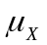).
CONVERGENCE IN PROBABILITY AND CONVERGENCE IN DISTRIBUTION
Problem 12. Let  be a discrete random variable with probability density function
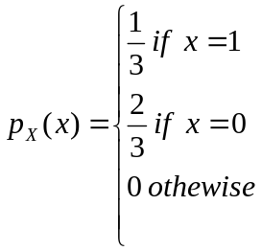
Consider a sequence of random variables 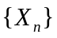 whose generic term is 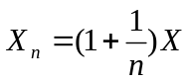. Prove that converges in probability to .

Problem 13: Let be a sequence of random variables having distribution functions
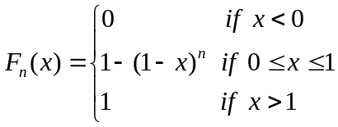.
Find the limit in distribution (if it exists) of the sequence .

